Internship Network Learning Report
Name: Jean-Luc Twite
Department: IT
Company: Frontier Mine
Reporting Period: Internship (Network Focus)
Main Supervisor: Mr Etienne

1. Introduction
This report presents an overview of the knowledge and practical skills I have acquired since I started working with the networking team at ERG Africa Frontier Mine. The objective of this report is to clearly describe the networking concepts I have learned, the hands-on activities I have participated in, and my understanding of the network infrastructure used within the mine environment.

Networking Concepts Learned

During my internship with the network team, I gained a foundational understanding of how devices communicate over a network using IP addresses. I learned the role of IP addressing in identifying devices and enabling communication between systems.
I also learned the difference between MAC addresses and IP addresses, including how MAC addresses identify network interfaces at the hardware level, while IP addresses are used for logical communication within and across networks.
Additionally, I learned the difference between:
- LAN (Local Area Network): Used to connect devices within the same site or location
- WAN (Wide Area Network): Used to connect networks across long distances and to the internet

VLANs (Virtual Local Area Networks)
I was introduced to the concept of VLANs and learned how they are used to logically separate network traffic within the same physical network. I learned that VLANs improve security, performance, and network organization by isolating different departments or services (such as IT, HR, CCTV, and access control) while using the same physical infrastructure.

Network Cabling
I gained hands-on experience in wiring and testing UTP (Unshielded Twisted Pair) cables. This included identifying faulty cables, replacing damaged cables, and ensuring proper termination for reliable connectivity.
I was also introduced to fiber optic cables, including their purpose in long-distance communication. I learned the basics of fiber optic splicing and understood why fiber is preferred for backbone and inter-building connections due to its high-speed, long-distance capability, and resistance to interference.

Network Devices
I learned the function and importance of network devices such as:
- Switches: Used to connect multiple devices within a LAN
- Core switch: Acts as the backbone of the network and connects all distribution and access switches, enabling high-speed communication between systems
- Difference between manageable and non-manageable switches and why manageable switches are required for VLAN configuration
I was also exposed to installing operating systems over the network, which helped me understand how network services support system deployment and configuration.

3. Overview of the ERG Frontier Network Infrastructure
At ERG Frontier Mine, the network infrastructure is designed to support critical mining operations, office systems, security systems, and remote departments.
3.1 Local Area Network (LAN)
The LAN starts from the core switch, which serves as the network backbone. The core switch connects to distribution and access switches located across different departments. This design allows high-speed and reliable communication between all systems within the site.
3.2 Wide Area Network (WAN) and Internet Connectivity
The WAN connects ERG Frontier Mine to the internet and external services. The site uses two Internet Service Providers:
- Liquid Telecom (primary connection)
- Orange (backup connection)
Liquid is prioritized for normal operations, while Orange is used as a failover link when the primary connection is unavailable.
3.3 Wireless and External Connectivity
Antennas are used to transmit and receive network traffic between remote locations and the main network. These wireless links allow connectivity where fiber or copper cabling is not feasible.

A firewall is implemented between the external network (internet/WAN) and the internal LAN. The firewall is responsible for securing the network by inspecting traffic and allowing or blocking data based on security rules. This ensures that only authorized and safe traffic is permitted into the ERG network.
Here below is a small architectural design of erg network
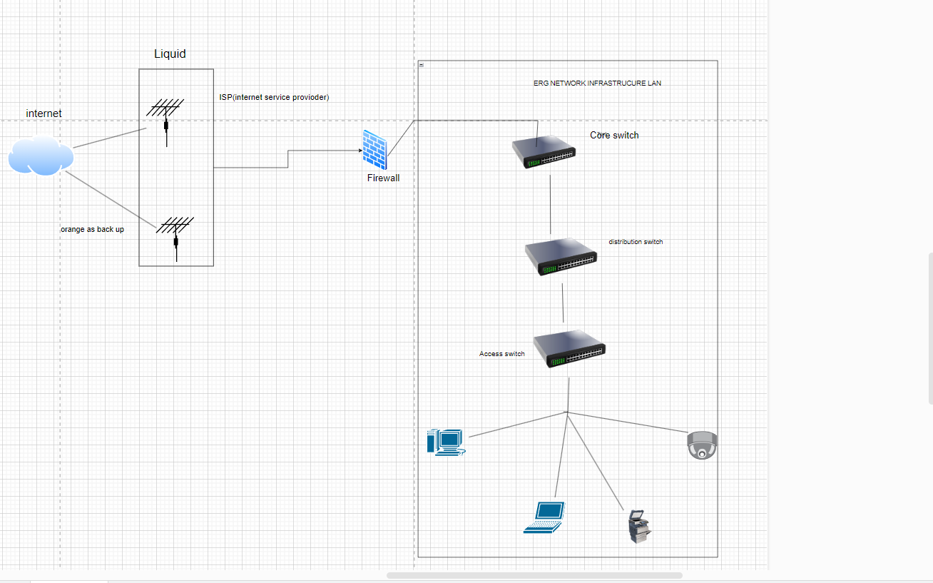

4. Practical Experience Gained
During my time with the network team, I actively participated in:
- Wiring and replacing UTP cables
- Troubleshooting network connectivity issues
- Assisting with fiber optic splicing activities
- Configuring and testing switches
- Understanding VLAN implementation
- Observing and learning network security practices

5. Conclusion
Working with the networking team at ERG Africa Frontier Mine has provided me with valuable practical experience and a solid foundation in networking principles. I have developed a better understanding of how enterprise and industrial networks are designed, implemented, and maintained in a mining environment.
This internship has strengthened my technical skills, improved my problem-solving abilities, and increased my interest in pursuing a career in networking and data-related fields. I am confident that the knowledge gained during this period will be beneficial for my future professional development.

